1. Do weekend games (Friday, Saturday, Sunday), on average, have a higher attendance than weekday games (Monday through Thursday)?

We aggregate the average number of audience by weekdays, and a illustration is as follows:

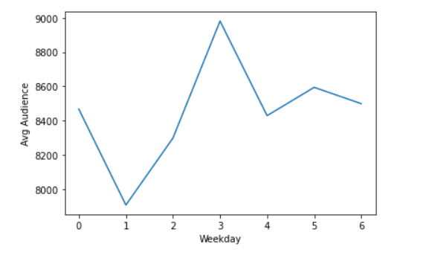

We assure that that audience is not closely related with Friday, Saturday and Sunday. Thursday has the most visitors.

|  |  |
| --- | --- |
| Weekday | Average number of visitors |
| Monday | 8467 |
| Tuesday | 7907 |
| Wednesday | 8298 |
| Thursday | 8981 |
| Friday | 8429 |
| Saturday | 8594 |
| Sunday | 8499 |

However, it seems that the number of visitors in Fri, Sat, Sun are higher than Mon, Tue, Wed, which proves influence by weekdays.

1. Identify and rank the top 4 opponents with the highest average number of attendances.

The top 4 teams are as follows:

|  |  |
| --- | --- |
| Team | Average number of audience |
| Celtics | 10101 |
| Warriors | 9797 |
| Laker | 9477 |
| Knicks | 9432 |

1. Identify and rank the top 10 sections that are, on average, the most filled to their capacity.

The top 10 sections with the most attendances as follows:

|  |  |
| --- | --- |
| Section | Average number of audience |
| 106 | 417 |
| 116 | 411 |
| 115 | 384 |
| 107 | 377 |
| 108 | 314 |
| 117 | 270 |
| 301 | 269 |
| 114 | 222 |
| 105 | 194 |
| 304 | 188 |

Meanwhile, by ratio of attendances, the top 10 is as follows:

|  |  |
| --- | --- |
| Section | Average ratio of audience |
| 15 | 0.7935 |
| 33 | 0.7989 |
| 3 | 0.7862 |
| 12 | 0.7816 |
| 20 | 200.7736 |
| 10 | 0.7730 |
| 14 | 0.7661 |
| 2 | 0.7644 |
| 34 | 0.7577 |
| 22 | 0.7535 |

1. Is there a correlation between opponent team having a higher Vegas Odds Score (indicating higher probability of winning a championship) and higher attendance?

The correlation between Vegas Odds and audience is smaller than expected:

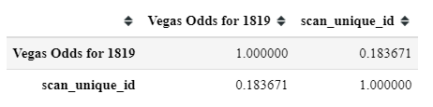

It partly because some teams bring great profits but with weak competence, a classical team of which is Knicks, relying on the great resources from New York.

1. On average, which 15-minute period before or after the start of a game has the highest number people scanning. (Example 30 – 16 minutes prior the start of a game).

As illustrated below, most of the attendances concentrate on around 100 minutes after start time. The 15 minutes with most audience entry starts at 108 minutes after start time.

